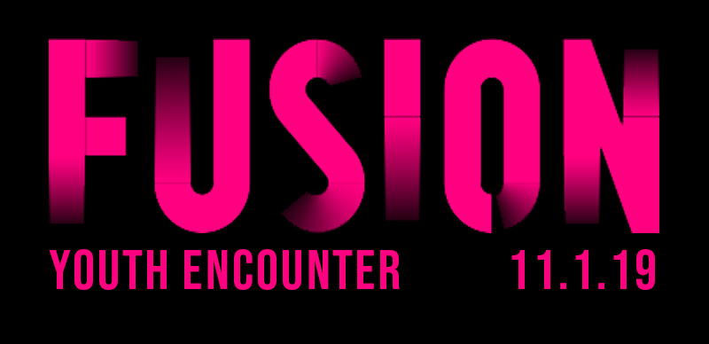

Impact Worship Experience: Registration-7:00pm Service-8:00pm
Trinity Church
3355 Dunckel Rd.
Lansing, MI

Impact Night Life: 11:30pm-5:00am

MAC
2900 Hannah Blvd.
East Lansing, MI

*The cost of Fusion Youth Encounter is $30 per person, after October 24, cost is $35.
One Chaperone FREE per 10 students registered.

cost includes: Impact service, pizza,
all activities at the MAC: swimming,
indoor basketball, tennis, and much more.

Pre-register by going to www.impactmi.org AND by mailing your group payment to:

Impact Youth Ministries, P.O. Box 187, St. Johns, MI 48879.

Make checks payable to PCG Youth Ministries. No refunds, transfers only.
Payment must be received to be pre-registered.
All unpaid balances must be made at Fusion Youth Encounter.

